A Major Project Report

On

**HUMAN-COMPUTER INTERACTION BASED EYE-CONTROLLED MOUSE**

Submitted in partial fulfillment of the

Requirements for the award of the degree

**BACHELOR OF TECHNOLOGY**

**IN**

**INFORMATION TECHNOLOGY**

Submitted By

**Brahma Routhu Sai Teja Varma (18H61A1209)**

**Sasi Kiran Reddy Kalam (18H61A1220)**

**Sujit Reddy Gaddam (18H16A1255)**

Under the guidance of

**Mr. A. Sriram**

Assistant Professor



**Department of Information Technology**

**ANURAG GROUP OF INSTITUTIONS**

**(An Autonomous Institution)**

**(Affiliated to JNTU-HYD, Approved by AICTE and NBA Accredited)**

**Venkatapur (V), Ghatkesar (M), Medchal district, Hyderabad, Telangana,500088**

**2018-2022**

**ANURAG GROUP OF INSTITUTIONS**

**(An Autonomous Institution)**

**(Affiliated to JNTU-HYD, Approved by AICTE and NBA Accredited)**

**Venkatapur (V), Ghatkesar (M), Medchal district, Hyderabad, Telangana,500088**

**Department of Information Technology**



**CERTIFICATE**

This is to certify that the project report entitled **“Human-Computer Interaction Based Eye Controlled Mouse”** is a Bonafide work done and submitted by **Brahma Routhu Sai Teja Varma (18H61A1209), Sasi Kiran Reddy Kalam (18H61A1220), and Sujit Reddy Gaddam (18H61A1255)** in partial fulfillment of the requirements for the award of the degree of B.Tech in **Information Technology from Anurag Group of Institutions (formerly CVSR College of Engineering),**Affiliated to Jawaharlal Nehru Technological University, Hyderabad during the academic year 2021-2022 and the Bonafide work has not been submitted elsewhere for the award of any other degree.

**Internal Guide                                                                                  H.O.D**

**Mr. A. Sriram                                                                      Dr. K. S. Reddy**

**Assistant Professor                                                                           Professor**

**Department of IT                                                                              Dean, Academics and Planning**

**External Examiner**

**ACKNOWLEDGEMENT**

We would like to express our sincere thanks to **Dr. K. S. Reddy**, Dean, Academics and Planning,Head of the Department of Information Technology, Anurag Group of Institutions, Ghatkesar, whose motivation in the field of software development has made us to overcome all hardships during the course of study and successful completion of project.

We would like to express our profound sense of gratitude to all for having helped us in completing this dissertation. We would like to express our deep-felt gratitude and sincere thanks to our guide

**Mr. A. Sriram,**Assistant Professor, Department of Information Technology, Anurag Group of Institutions, Ghatkesar, for his skillful guidance, timely suggestions and encouragement in completing this project.

We extend our sincere thanks to **Dr. G. Vishnu Murthy**, Dean, School of Engineering,

**Dr. K. S. Reddy**, Dean, Academics and Planning,Head of the Department of Information Technology, of **Anurag Group of Institutions**, Venkatapur(V), Ghatkesar(M), R. R. Dist, for their encouragement and constant help.

Finally, we would like to express our heartfelt thanks to our parents who were very supportive both financially and mentally and for their encouragement to achieve our set goals.

**Brahma Routhu Sai Teja Varma (18H61A1209)**

**Sasi Kiran Reddy Kalam (18H61A1220)**

**Sujit Reddy Gaddam (18H61A1255)**

   
   
   
 

**DECLARATION**

This is to Certify that the project work entitled “**HUMAN-COMPUTER INTERACTION BASED EYE-CONTROLLED MOUSE”** submitted to Anurag Group of Institutions in partial fulfillment of the requirement for the award of the Degree of Bachelor of Technology (B-Tech), is an original work carried out by **Brahma Routhu Sai Teja Varma** (**18H61A1209), Sasi Kiran Reddy Kalam (18H61A1220), Sujit Reddy Gaddam (18H61A1255)**under the guidance of **Mr. A. Sriram,** Assistant Professorin the Department of Information Technology. This matter embodied in this project is a genuine work, done by the students and has not been submitted whether the university or to any other university/Institute for the fulfillment of the requirement of any course of study.

**Brahma Routhu Sai Teja Varma (18H61A1209)**

**Sasi Kiran Reddy Kalam (18H61A1220)**

**Sujit Reddy Gaddam (18H61A1255)**

   
   
   
   
   
   
   
   
 

**ABSTRACT**

With advanced technologies in this digital era, there is always scope for development in the field of computing. Hands-free computing is in demand as of today it addresses the needs of quadriplegics (people affected by paralysis of all four limbs). Here, we propose to present a Human-Computer Interaction (HCI) system that is of great importance to amputees and those who have issues with using their hands. The system built is an eye-based interface that acts as a computer mouse to translate eye movements such as blinking, gazing, and squinting towards the mouse cursor actions. This system plans to make use of a simple webcam and its software requirements are Python, OpenCV, NumPy, and a few other packages which are necessary for face recognition. The face detector can be built using the HOG (Histogram of Oriented Gradients) feature along with a linear classifier, and the sliding window technique. It is hands-free and no external hardware or sensors are required.

   
   
   
   
   
   
   
   
   
   
   
   
   
   
   
   
   
   
   
 

**CONTENTS**

**CHAPTERS** **PAGENO**

**List of Figures** .....................................................................................................i

**List of Tables** ......................................................................................................iii

**List of Abbreviations**..........................................................................................iv

1. **Introduction**

1.1 Overview..................................................................................................1

1.2 Objectives ................................................................................................1

1.3 Problem Formulation ...............................................................................2

1.4 Scope of the Project .................................................................................2

1.5 Feasibility..................................................................................................2

1.6. Requirements of the Project ....................................................................3

1.6.1 Software Requirements ..................................................................3

1.6.2 Hardware Requirements .................................................................3

1. **Requirements Specification**

2.1 Functional Requirements.........................................................................4

2.1 Non-Functional Requirements.................................................................5

2.3 User Interface...........................................................................................6

2.4 Constraints, Prerequisite ……..................................................................7

**3**. **Analysis**

3.1 Existing System .......................................................................................9

3.2 Proposed System.......................................................................................9

3.3 Use Case models.......................................................................................10

**4. Design**

4.1 System Architecture...................................................................................15

4.2 Class Diagram............................................................................................16

4.3 Sequence Diagram......................................................................................17

**5. Implementation**

5.1 Approach Used…………………………………………………………..20

5.2 Technologies Used……………………………………………………….21

5.3 Modules…………………………………………………………………23

5.4 Code Snippets…………………………………………………………...27

**6. User Screens.....................................................................................................39**

**7. Testing Methodology………………………………………………………...47**

**8. Conclusion and Future Enhancements..........................................................49**

**9. References.........................................................................................................50**

**LIST OF FIGURES**

|  |  |  |
| --- | --- | --- |
| **Figure Number** | **Name of Figure** | **Page No** |
| 2.3.1 | GUI Interface – Before Clicking Start | 6 |
| 2.3.2 | GUI Interface – After Clicking Start | 6 |
| 2.3.3 | Camera Frame Opens up | 7 |
| 2.4.1 | Installed Packages | 8 |
| 3.3.1 | Use Case Diagram | 10 |
| 3.3.2 | State Chart Diagram | 11 |
| 3.3.3 | Activity Diagram | 12 |
| 3.3.4 | Component Diagram | 13 |
| 3.3.5 | Data Flow Diagram | 14 |
| 4.1.1 | System Architecture | 15 |
| 4.2.1 | Class Diagram | 16 |
| 4.3.1 | Sequence Diagram | 17 |
| 5.0.1 | Diving an image into cells | 18 |
| 5.0.2 | Cell to Histogram | 19 |
| 5.0.3 | Histogram to feature vector | 19 |
| 5.1.1 | Spiral Model | 20 |
| 5.3.3 | Facial Landmarks – 68 points | 24 |
| 5.3.4.1 | Eye-Aspect-Ratio (EAR) | 25 |
| 5.3.4.2 | Mouth-Aspect-Ratio (MAR) | 25 |
| 5.3.5.1 | Operations Performed | 26 |
| 6.1 | Activating the mouse – Reading Input | 39 |
| 6.2 | Moving the mouse pointer Left | 40 |
| 6.3 | Moving the mouse pointer Right | 41 |
| 6.4 | Moving the mouse pointer Up | 42 |
| 6.5 | Moving the mouse pointer Down | 43 |
| 6.6 | Scrolling the pointer Upwards | 44 |
| 6.7 | Scrolling the pointer Downwards | 45 |
| 6.8 | Deactivating the mouse | 46 |

**LIST OF TABLES**

|  |  |  |
| --- | --- | --- |
| **TABLE NUMBER** | **TABLE NAME** | **PAGE NUMBER** |
| 7.1 | Test Cases | 47 |

**ABBREVIATIONS**

|  |  |
| --- | --- |
| **TERMS** | **DEFINITION** |
| HCI | Human Computer Interaction |
| HOG | Histogram of Oriented Gradients |
| SVM | Support Vector Machine |
| EAR | Eye Aspect Ratio |
| MAR | Mouth Aspect Ratio |

**1. INTRODUCTION**

The computer mouse or moving the finger has been a very common approach to move the cursor along the screen in the current technology. The system detects any movement in the mouse or the finger to map it to the movement of the cursor. Some people, who do not have their arms to be operational, called as ‘amputees’ will not be able to make use of the current technology to use the mouse. Hence, if the movement of their eyeball & facial features can be tracked and if the direction towards which the eye is looking at can be determined, the movement of the facial features can be mapped to the cursor and the amputee will be able to move the cursor at will. An ‘eye-tracking mouse’ will be of a lot of use to an amputee.

**1.1. Overview**

Our Project performs the following functions or actions which are as follows.

1. Opening the Mouth
2. Right Eye Wink
3. Left Eye Wink
4. Squinting Eyes
5. Head Movements (Pitch and Yaw)

Since the project is based on detecting the features of the face and mapping them to the cursor, the webcam needs to be accessed first, which means that the webcam will be opened. Once the webcam is opened, the program needs to extract every frame from the video. The frame-rate of the video is generally around 30 frames per second, so a frame at every 1/30th of a second will be used to be processed. This frame undergoes a set of processes before the features of the frame are detected and mapped to the cursor. And this process continuously takes place for every frame as a part of a loop.

Once the frame is extracted, the regions of the face need to be detected. Hence, the frames will undergo a set of image-processing functions to process the frame in a suitable way, so that it is easy for the program to detect the features such as eyes, mouth, nose, etc.

**1.2. Objective**

The objective of our project is to make the work of ‘amputees’ (people who don’t have their arms to be operational) easy. With the help of our project Amputees or quadriplegics (people affected by paralysis of all four limbs) can use and operate the mouse using their facial features and actions of their eyes.

This Project undertakes to develop a system that will only use a webcam to use human eyes and facial features as a pointing device for the computer system to provide a user-friendly human-computer interaction project. The objectives are outlined below:

1. Face and Eyes Detection
2. Eye Corners extraction
3. Develop an algorithm to calculate point of gaze-based on eye features found
4. Develop a GUI to show results
5. Develop a simple Calibration technique

**1.3. Problem Formulation**

The computer mouse or moving the finger has been a very common approach to moving the cursor along with the screen in the current technology. The system detects any movement in the mouse or the finger to map it to the movement of the cursor. An HCI-based eye-tracking mouse’ will be of a lot of use to an amputee. Currently, the eye-tracking mouse is not available on a large scale, and only a few companies have developed this technology and have made it available. In our current system, to get an accurate image of the iris an IR sensor should be used. And a gyroscope can be used for the orientation of the head but this method requires the appropriate hardware. So in our project, instead of using only the eye gaze and actions to track the mouse, we will be using eye gestures along with facial expressions.

**1.4. Scope**

The project is wide in scope. Our project the ‘Human-Computer Interaction based eye-controlled mouse’ is an application that will be very helpful to ‘Amputees’ in controlling the mouse by using just the eye gestures and facial expressions. The benefits of using our project are as follows:

1. Easier computer control,
2. Help disabled & handicapped people to use computer
3. Helpful in commercial interactive games and advertisements

**1.5. Feasibility**

Feasibility analysis begins once the goals are defined. The feasibility of a new system means ensuring that the new system, which we are going to implement, is efficient and affordable. It is important to not exert considerable effort at this stage only to find out that the project is not worthwhile or that there is a need to significantly change the original goal.

**1.5.1 Economical Feasibility**

The development of this application is highly economically feasible. It is cost-effective in the sense that has eliminated the use of extensive Hardware equipment like the IR sensor, Gyroscope etc.

**1.5.2 Technical Feasibility**

The technical requirement for the system is economic and it does not use any other additional hardware. Technical feasibility evaluation must also assess whether the existing system can be upgraded to use the new technology and whether we have the expertise to use it. This is all true for our application.

**1.5.3 Operational Feasibility**

The system working is quite easy to use and learn due to its simple interface. This project undertakes to develop a system that will only use a webcam and uses human eyes and facial gestures as a pointing device. The user requires no special training for operating the system.

**1.6 System Requirements**

* + 1. **Software Requirements**
* Google Chrome browser
* Programming Language: Python
* IDE: PyCharm/Jupyter
  + 1. **Hardware Requirements**
* Memory: 8-GB RAM
* Display: Resolution of 1024 x 768
* Processor: Intel CORE i5 8th GEN (1.6 gigahertz (GHz)).

**2. REQUIREMENTS SPECIFICATION**

**2.1. Functional Requirements**

Functional requirements should include functions performed by a specific screen, outline work-flows performed by the system, and other business or compliance requirements the system must meet. Functional requirements specify which output file should be produced from the given file, they describe the relationship between the input and output of the system, for each functional requirement a detailed description of all data inputs and their source and the range of valid inputs must be specified. If a user requirement specification was written, all requirements outlined in the user requirements specifications should be addressed in the functional requirements.

**Functionality 2.1.1. Eye Detection**

There is a variety of computer applications that identify the eye in digital images, like- security systems, criminal identification, healthcare, and so on. The eye-detection algorithms focus on the detection of the frontal human eye. The Python OpenCV library functions are mainly aimed at real-time computer vision. It is mainly used to do all the operations for image processing as well as detecting objects. OpenCV already contains many pre-trained classifiers for face, eyes, smile, etc.

**Functionality 2.1.2. Eye Blink Detection**

Here in the project, we will use the python language along with the OpenCV library for the algorithm execution and image processing respectively. The haar cascades we are going to use in the project are pre trained and stored along with the OpenCV library.

**Functionality 2.1.3. Eye and Mouth Moment Detection**

Eye and mouth state analysis is an important step in fatigue detection. An algorithm that analyzes the state of the eye and mouth by extracting contour features is proposed. First, the face area is detected in the acquired image database. The Dlib prebuilt model helps in fast and accurate face detection along with 68 2D facial landmarks as explained already. Here, Eye-Aspect-Ratio (EAR) and Mouth-Aspect-Ratio (MAR) are used to detect blinking/winking and yawing respectively.

**Functionality 2.1.4. Head Movement Detection**

Head movement is also found to be a natural, simple and effective way of pointing to objects, interaction and communication. Thus, head movement detection has received significant attention in recent research. One of the various purposes for head movement detection and tracking is to allow the user to interact with a computer. It also provides the ability to control many devices by mapping the position of the head into control signals. But in our project, we use it for controlling the mouse.

**Functionality 2.1.5. Mouse Cursor Controlling**

This HCI (Human-Computer Interaction) application in Python (3.6) will allow you to control your mouse cursor with your facial movements, works with just your regular webcam. Its hands-free, no wearable hardware or sensors needed.

**2.2. Non-Functional Requirements**

Describe user-visible aspects of the system that are not directly related to the functional behavior of the system. Non-Functional requirements include quantitative constraints, such as response time (i.e. how fast the system reacts to user commands.) or accuracy (i.e. how precise are the system’s numerical answers.)

**2.2.1. Portability**

Portability requirements are non-functional requirements and focus on the ability of two or more components or systems to perform their required functions while all of these are in the same environment.

**2.2.2. Reliability**

Reliability is an important non-functional requirement for most software products so a software requirements specification (SRS) should contain a reliability requirement, and most do. But, one of our indicators of the quality of a ‘good’ requirement is that it is testable, so it is reasonable to ask whether the reliability requirements in an SRS are testable as written.

**2.2.3. Usability**

Usability is a non-functional requirement, because in its essence it doesn't specify parts of the system functionality, only how that functionality is to be perceived by the user, for instance how easy it must be to learn and how efficient it must be for carrying out user tasks.

**2.3 User Interface**

**2.3.1. GUI Interface-1**

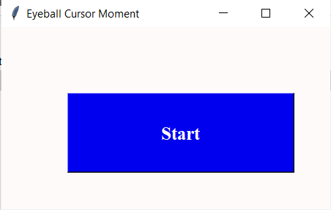

Figure 2.3.1 GUI Interface – Before Clicking Start

This is the GUI interface and there is a blue start button and after clicking this button the following operation takes place.

**2.3.2. GUI Interface-2**

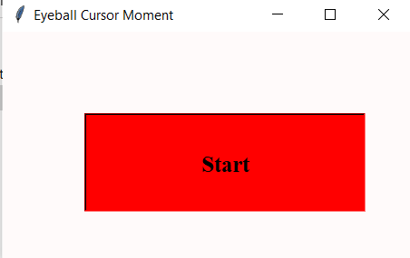

Figure 2.3.2 GUI Interface – After Clicking Start

This is another GUI Interface which is a red Start button that comes up after clicking the first blue start button.

**2.3.3. Camera Frame Interface**

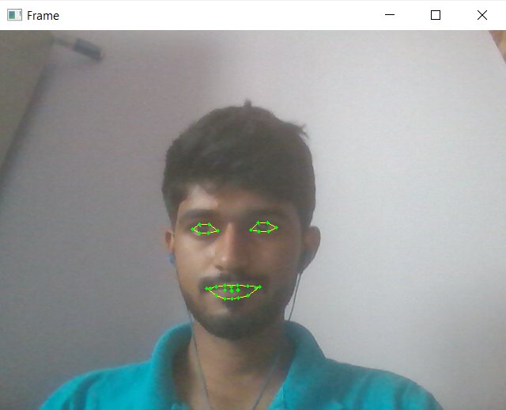

Figure 2.3.3 Camera Frame Opens up

Here the camera frame opens up after clicking the start button. And here it’s detecting the eyes and mouth and its being shown through counters drawn.

**2.4. Constraints, Prerequisite**

There are some prerequisites for this project. In this project, we need to install Anaconda and create a conda environment so that it will be organized and easy to work in. We also need to install some packages using commands in the anaconda prompt.

* Opencv-python
* Pyautogui
* Conda-forge
* dlib

The above two packages need to be pip installed using the command ‘pip install’. Whereas the last two packages must be installed using the command ‘conda install –c’

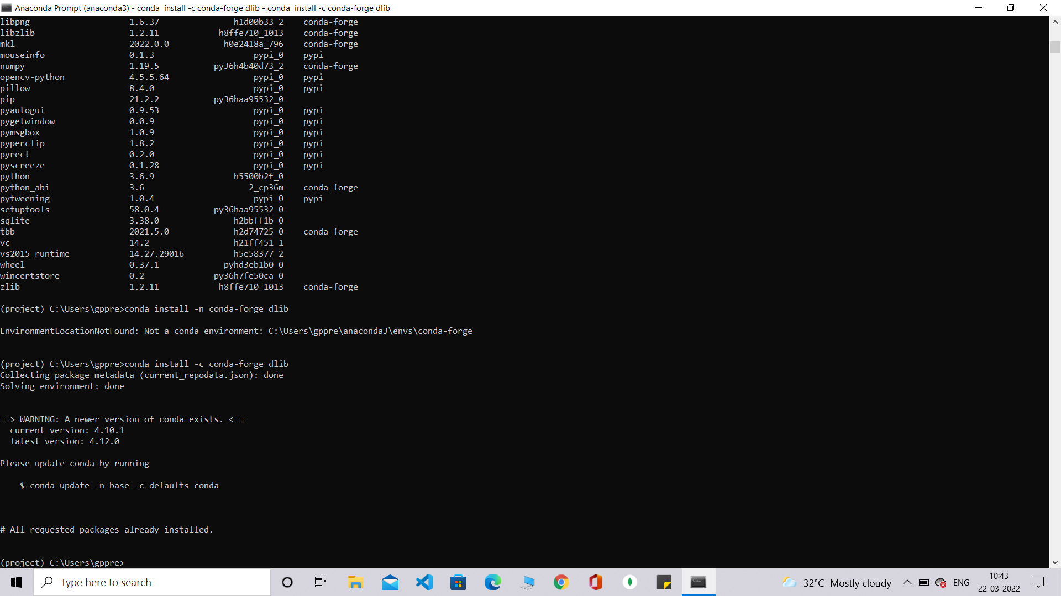

Figure 2.4.1 Installed Packages

**3. ANALYSIS**

**3.1. Existing System**

The computer mouse or moving the finger has been a very common approach to move the cursor along with the screen in the current technology. The system detects any movement in the mouse or the finger to map it to the movement of the cursor. Some people, who do not have their arms to be operational, called ‘amputees’ will not be able to make use of the current technology to use the mouse. Hence, if the movement of their eyeball can be tracked and if the direction towards which the eye is looking can be determined, the movement of the eyeball can be mapped to the cursor and the amputee will be able to move the cursor at will. An ‘HCI-based eye-tracking mouse’ will be of a lot of use to an amputee. Currently, the eye-tracking mouse is not available on a large scale, and only a few companies have developed this technology and have made it available. The following are some drawbacks of Existing System.

* In the existing system, to get an accurate image of the iris an IR sensor should be used.
* And a gyroscope can be used for the orientation of the head but this method requires the appropriate hardware.
* So in our project, instead of using only the eye gaze and actions to track the mouse, we will be using eye gestures along with facial expressions.

**3.2. Proposed System**

The proposed system has the following actions.

* Opening the Mouth
* Right Eye Wink
* Left Eye Wink
* Squinting Eyes
* Head Movements (Pitch and Yaw)

Since the project is based on detecting the features of the face and mapping them to the cursor, the webcam needs to be accessed first, which means that the webcam will be opened. Once the webcam is opened, the program needs to extract every frame from the video. This frame undergoes a set of processes before the features of the frame are detected and mapped to the cursor. And this process continuously takes place for every frame as a part of a loop. The advantages of proposed system are as follows.

* Hands-free mouse cursor control system.
* Facilitating the incapacitated.
* Mouse pointer control through eye movements and facial expressions.
* Simulating mouse functions, performing different mouse functions such as left click, right click, double click and so on using their eyes and facial features.

**3.3. Use case models**

**3.3.1. Use case Diagram**

In the Unified Modeling Language (UML), a use case diagram can summarize the details of your system's users (also known as actors) and their interactions with the system. To build one, you'll use a set of specialized symbols and connectors.

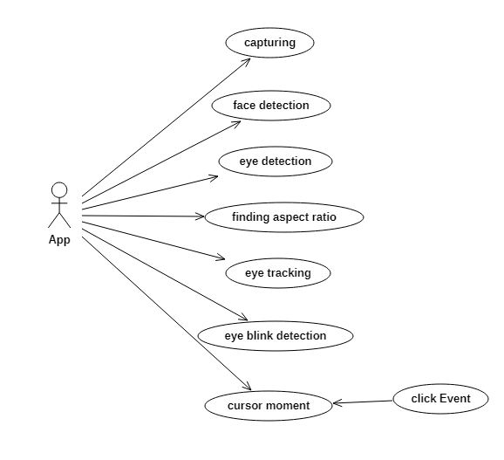

Figure 3.3.1 Use Case Diagram

This use case diagram tells about the flow of the project by even mentioning about the actors. The actor here is the Application.

**3.3.2. State Chart Diagram**

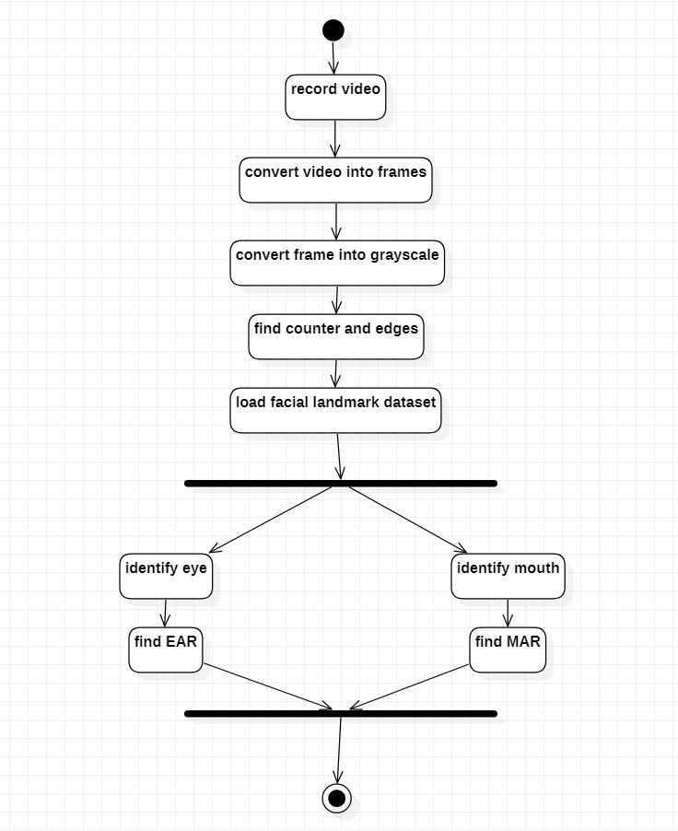The name of the diagram itself clarifies the purpose of the diagram and other details. It describes different states of a component in a system. The states are specific to a component/object of a system. A Statechart diagram describes a state machine. State machine can be defined as a machine which defines different states of an object and these states are controlled by external or internal events.

Figure 3.3.2 Start Chart Diagram

In this diagram the flow is described. It has two points such as start and end. The flow is user records the video, convert it into frames and then into grayscale then loads the facial landmark dataset before identifying the MAR and EAR.

**3.3.3. Activity Diagram**

An activity diagram is a behavioral diagram i.e. it depicts the behavior of a system. An activity diagram portrays the control flow from a start point to a finish point showing the various decision paths that exist while the activity is being executed. We can depict both sequential processing and concurrent processing of activities using an activity diagram.

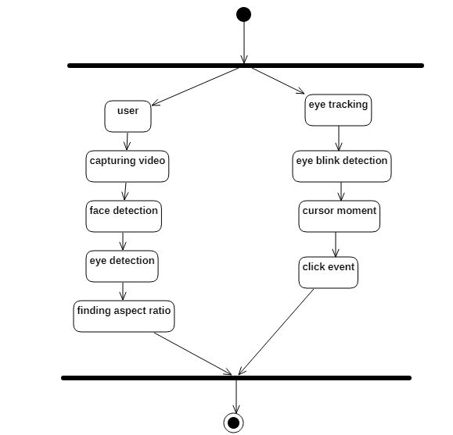

Figure 3.3.3 Activity Diagram

This activity diagram shows that the two operations can be performed simultaneously and this can be depicted using the fork operation. At one end the user captures video, detects face, detects eyes, and finds ratios, whereas at the other end eye tracking, eye blink detection and click event operations are performed.

**3.3.4. Component Diagram**

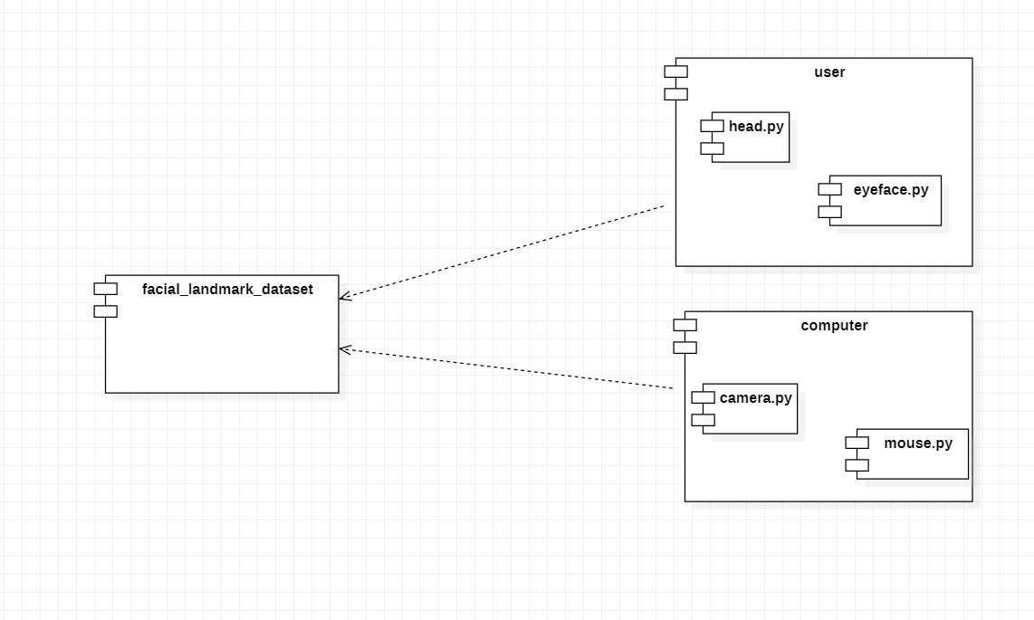A component diagram is used to break down a large object-oriented system into the smaller components, so as to make them more manageable. It models the physical view of a system such as executables, files, libraries, etc. that resides within the node. It visualizes the relationships as well as the organization between the components present in the system. It helps in forming an executable system. A component is a single unit of the system, which is replaceable and executable.

Figure 3.3.4. Component Diagram

There are different components in this diagram such as user, computer and facial landmark dataset. Here, the user and computer are connected to the facial landmark dataset. This diagram describes about the components used in the project.

**3.3.5. Data Flow Diagram**

A data flow diagram (DFD) maps out the flow of information for any process or system. It uses defined symbols like rectangles, circles and arrows, plus short text labels, to show data inputs, outputs, storage points and the routes between each destination.  They can be used to analyze an existing system or model a new one.

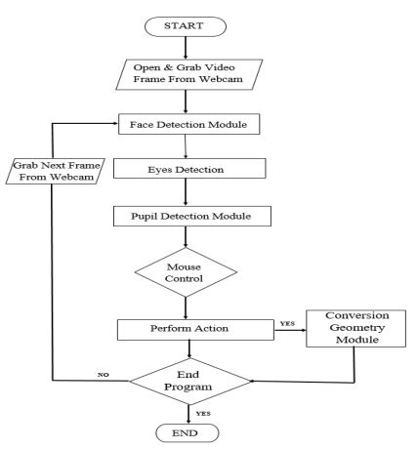

Figure 3.3.5. Data Flow Diagram

According to this data flow diagram, first the open and grab video frame from the webcam takes place. After that the face, eyes and pupils are detected and the respective mouse operations are performed by controlling the mouse. These operations are performed in a loop till the Programs ends.

**4. DESIGN**

**4.1. System Architecture**

In reference to computers, software or networks, the overall design of a computing system and the logical and physical interrelationships between its components. A system architecture is the conceptual model that defines the structure, behavior, and more views of a system. An architecture description is a formal description and representation of a system, organized in a way that supports reasoning about the structures and behaviors of the system.

A system architecture can consist of system components and the sub-systems developed that will work together to implement the overall system. There have been efforts to formalize languages to describe system architecture, collectively these are called architecture description languages (ADLs).

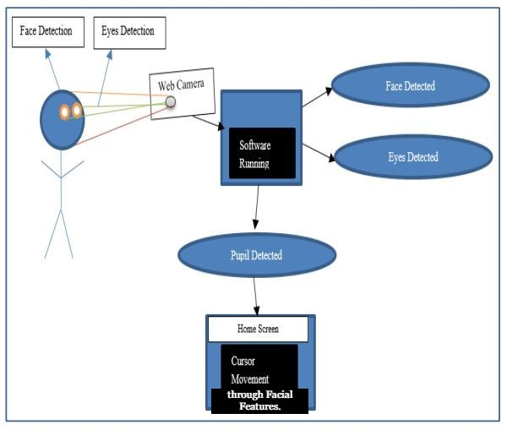

Figure 4.1.1 System Architecture

**4.2. Class Diagram**

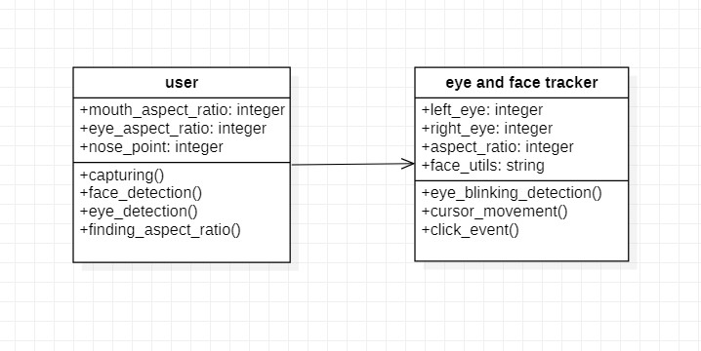The most widely use UML diagram is the class diagram. It is the building block of all object-oriented software systems. We use class diagrams to depict the static structure of a system by showing system’s classes, their methods and attributes. Class diagrams also help us identify relationship between different classes or objects.

Figure 4.2.1 Class Diagram

The above is the class diagram for our system and it has two classes namely User class and Eye and face tracker class. Both classes have their respective attributes and operations which are performed under them. Each class has its own attributes as well as operations. These operations helps to do the tasks. It shows the attributes, classes, functions, and relationships to give an overview of the software system. It constitutes class names, attributes, and functions in a separate compartment that helps in software development. Since it is a collection of classes, interfaces, associations, collaborations, and constraints, it is termed as a structural diagram.

**4.3. Sequence Diagram**

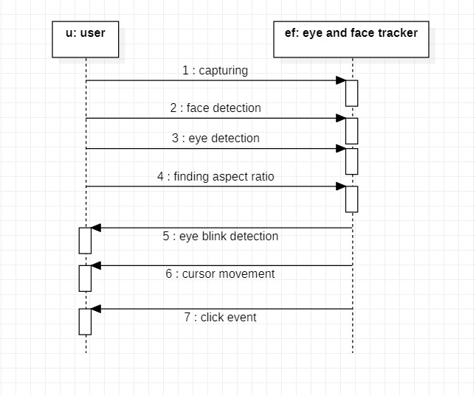A sequence diagram simply depicts interaction between objects in a sequential order i.e. the order in which these interactions take place. We can also use the terms event diagrams or event scenarios to refer to a sequence diagram. Sequence diagrams describe how and in what order the objects in a system function. These diagrams are widely used by businessmen and software developers to document and understand requirements for new and existing systems.in which these interactions take place. We can also use the terms event diagrams or event scenarios to refer to a sequence requirements for new and existing systems.

Figure 4.3.1 Sequence Diagram

The sequence diagram represents the flow of messages in the system and is also termed as an event diagram. It helps in envisioning several dynamic scenarios. It portrays the communication between any two lifelines as a time-ordered sequence of events, such that these lifelines took part at the run time. In UML, the lifeline is represented by a vertical bar, whereas the message flow is represented by a vertical dotted line that extends across the bottom of the page.

It incorporates the iterations as well as branching. This diagram has two classes namely user and eye and face tracker class respectively.

**5. IMPLEMENTATION**

Currently, for face detection, perhaps deep learning models perform the best. But face detection was there before the emergence of deep learning as well. Earlier, classical feature descriptors and linear classifiers were a really good solution for face detection. And the Dlib library provides one such classical solution for face detection. That is, HOG and Linear SVM.

This is based on the **HOG** (Histogram of Oriented Gradients) feature descriptor with a **Linear SVM** machine learning algorithm to perform face detection.

HOG is a simple and powerful feature descriptor. It is not only used for face detection but also it is widely used for object detection like cars, pets, and fruits. HOG is robust for object detection because object shape is characterized using the local intensity gradient distribution and edge direction.

**Step 1:**

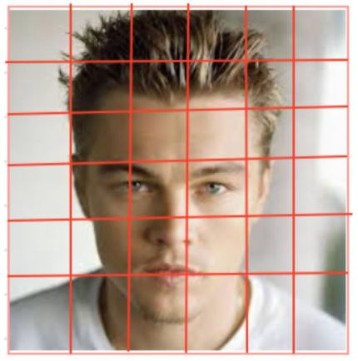The basic idea of HOG is dividing the image into small connected cells.

Figure 5.0.1. Dividing an image into cells

**Step 2:**

Computes the histogram for each cell.

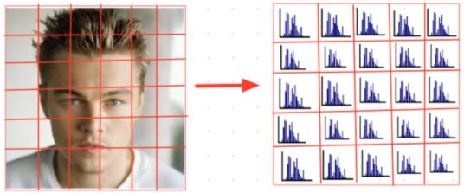

Figure 5.0.2. Cell to Histogram

**Step 3:**

Bring all histograms together to form a feature vector i.e., it forms one histogram from all small histograms which is unique for each face.

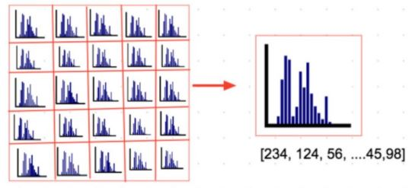

Figure 5.0.3. Histogram to feature vector

**5.1 Approach Used**

Spiral Model was defined by Barry Boehm in his 1988 article, “A spiral Model of Software Development and Enhancement”. This model was not the first model to discuss iterative development, but it was the first model to explain why the iteration models. As originally envisioned, the iterations were typically 6 months to 2 years long. Each phase starts with a design goal and ends with a client reviewing the progress thus far. Analysis and engineering efforts are applied at each phase of the project, with an eye toward the end goal of the project. The following diagram shows how a spiral model acts like.

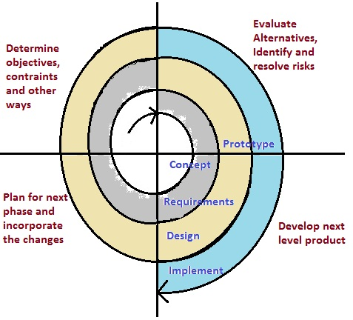

Figure 5.1.1. Spiral Model

The steps for Spiral Model can be generalized as follows:

* The new system requirements are defined in as much details as possible.
* This usually involves interviewing a number of users representing all the external or internal users and other aspects of the existing system.
* A preliminary design is created for the new system.
* A first prototype of the new system is constructed from the preliminary design. This is usually a scaled-down system, and represents an approximation of the characteristics of the final product.
* A second prototype is evolved by a fourfold procedure:

1. Evaluating the first prototype in terms of its strengths, weakness, and risks.
2. Defining the requirements of the second prototype.
3. Planning a designing the second prototype.
4. Constructing and testing the second prototype.

* At the customer option, the entire project can be aborted if the risk is deemed too great. Risk factors might involve development cost overruns, operating-cost miscalculation, or any other factor that could, in the customer’s judgment, result in a less-than-satisfactory final product.
* The existing prototype is evaluated in the same manner as was the previous prototype, and if necessary, another prototype is developed from it according to the fourfold procedure outlined above.
* The preceding steps are iterated until the customer is satisfied that the refined prototype represents the final product desired.
* The final system is constructed, based on the refined prototype.

The final system is thoroughly evaluated and tested. Routine maintenance is carried on a continuing basis to prevent large-scale failures and to minimize downtime.

**5.2. Technologies Used**

**5.2.1. Python**

Python is an interpreted high-level general-purpose programming language. Its design philosophy emphasizes code readability with its use of significant indentation. Its language constructs as well as its object-oriented approach aim to help programmers write clear, logical code for small and large-scale projects.

Python is dynamically-typed and garbage-collected. It supports multiple programming paradigms, including structured (particularly, procedural), object-oriented and functional programming. It is often described as a "batteries included" language due to its comprehensive standard library.

Guido van Rossum began working on Python in the late 1980s, as a successor to the ABC programming language, and first released it in 1991 as Python 0.9.0. Python 2.0 was released in 2000 and introduced new features, such as list comprehensions and a cycle-detecting garbage collection system (in addition to reference counting). Python 3.0 was released in 2008 and was a major revision of the language that is not completely backward-compatible. Python 2 was discontinued with version 2.7.18 in 2020.

**5.2.2. Anaconda IDE**

Anaconda is the data science platform for data scientists, IT professionals, and business leaders of tomorrow. It is a distribution of Python, R, etc. With more than 300 packages for data science, it becomes one of the best platforms for any project.

Anaconda is an open-source distribution for python and R. It is used for data science, machine learning, deep learning, etc. With the availability of more than 300 libraries for data science, it becomes fairly optimal for any programmer to work on anaconda for data science.

Anaconda helps in simplified package management and deployment. Anaconda comes with a wide variety of tools to easily collect data from various sources using various machine learning and AI algorithms. It helps in getting an easily manageable environment setup that can deploy any project with the click of a single button.

**5.2.3. Libraries used**

**Numpy**

Used for Matrix Processing

**Pyautogui**

Moving the mouse and clicking or typing in the windows of other applications.

**Imutils**

I just open-sourced my personal imutils package, a series of OpenCV + convenience functions for translation, rotation, resizing, and skeletonization.

**Dlib**

Dlib is a general purpose cross-platform software library written in the programming language C++.Its design is heavily influenced by ideas from design by contract and component-based software engineering.

**OpenCV2**

OpenCV is a cross-platform library using which we can develop real-time computer vision applications.

**5.3 Modules**

**5.3.1. Resizing**

The image is first flipped over the y-axis. Next, the image needs to be resized. The resize function refers to setting the new resolution of the image to any value as per the requirement. In this project, the new resolution is 640 X 480.

**5.3.2. BGR to gray**

The data that we are using to detect the different parts of the face requires image of a grayscale format to give more accurate results. Hence, the image, i.e. the frame of the video from the webcam needs to undergo the process of converting its format from RGB to grayscale. Once the image is converted to a grayscale format, it can be used to locate the face and identify the features of the face.

**5.3.3. Detection and prediction of facial features**

To detect the face and the features, a prebuilt model will be used in the project, which has the available values that can be interpreted by python to make sure that the face is located in the image. There is a function called ‘detector’, made available by the models, which helps us to detect the face. After the face is detected, the features of the face can now be detected using the function ‘predictor’.

The function helps us to locate 68 points on any 2D image. These points correspond to different points on the face near the required parts such as the eyes, mouth, etc.

The values of the function that are obtained are in the form of 2D coordinates. Every one of the 68 points are essentially the values of x and y coordinates that, when connected, will roughly form an identifiable face.

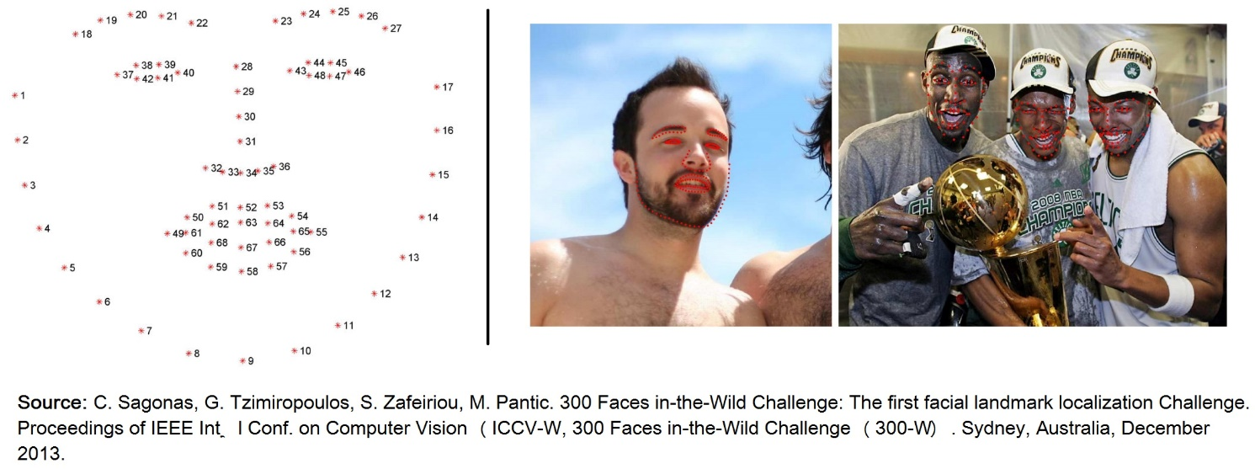Figure 5.3.3. Facial Landmarks – 68 points

They are then stored as an array of values so that they can be arranged and used in the next step to connect any of the coordinates and draw a boundary to represent the required regions of the face. Four sets of arrays are taken as 4 different parts of these values which are stored in the array, to separately be stored as the coordinates to be connected to represent the required regions, those are the: Left eye, Right eye, nose, and the mouth. Once the 4 arrays are prepared, boundaries, or ‘contours’ are drawn around the points using 3 of these arrays by connecting these points.

**5.3.4. MAR (Mouth Aspect Ratio) & EAR (Eye Aspect Ratio)**

Once the contours are drawn, it is necessary to have a reference for the shapes, which, when compared with, gives the program any information about any action made by these regions such as blinking, yawing, etc.

These references are understood as ratios, between the 2D coordinates, and a change in the coordinates, essentially tell us that, the parts of the region of the face have moved from the regular position and an action has been performed.

The system is built on predicting facial landmarks of the face. The Dlib prebuilt model helps in fast and accurate face detection along with 68 2D facial landmarks as explained already. Here, Eye-Aspect-Ratio (EAR) and Mouth-Aspect-Ratio (MAR) are used to detect blinking/winking and yawing respectively. These actions are translated into mouse actions.

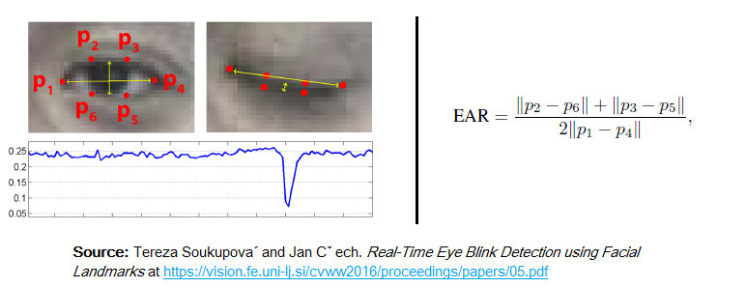**Eye-Aspect-Ratio (EAR)**

Figure 5.3.4.1. Eye-Aspect-Ratio (EAR)

The graph shows that EAR value drops drastically when the eye is closed. This trigger can be used for clicking action.

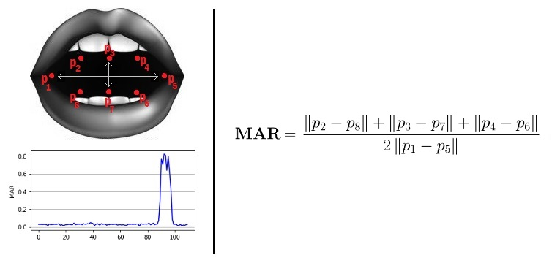**Mouth-Aspect-Ratio (MAR)**

Figure 5.3.4.2. Mouth-Aspect-Ratio (MAR)

Similarly, The MAR goes up when the mouth opens. This is used as an action to start and switch off the mouse. For example, if the ratio has increased, it can mean that the distances between the points representing the region of the face have changed and an action has been performed by the person. This action is supposed to be understood as the person trying to perform an operation using the mouse.

**5.3.5. Detection of actions performed by the face**

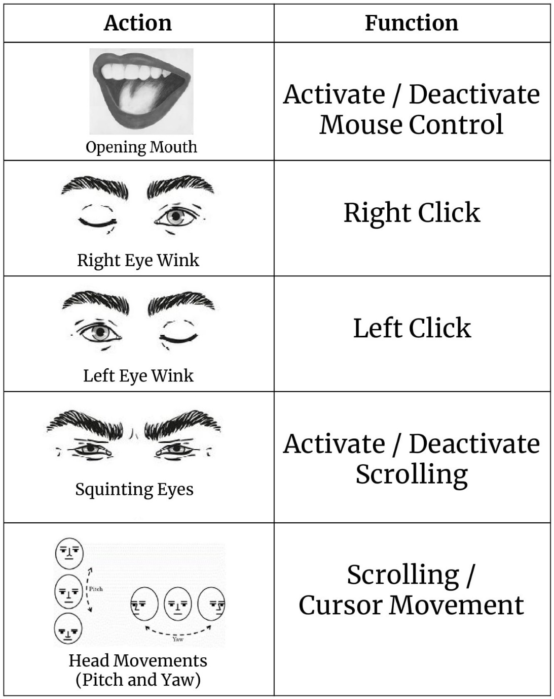After the ratios are defined, the frame can now compare the ratios of the parts of the face with the ratios defined for different actions, of the current frame being processed. It is done using the ‘if’ statement. The actions that the program identifies are as follows.

Figure 5.3.5.1 Operations Performed

1. **For activating/deactivating the mouse**

The user needs to ‘yaw’ which is opening his mouth, vertically, in turn increasing the distance between the corresponding 2D points of the mouth. The algorithm detects the change in the distance by computing the ratio, and when this ratio crosses a specified threshold, the system is activated and the cursor can be moved. But, again performing the ‘yaw’ operation deactivates the mouse.

1. **Left/Right-Clicking**

For clicking, he needs to close any one of his eye, and make sure to keep the other open. The program first checks whether the magnitude of the difference is greater than the prescribed threshold by using the difference between the ratios of the two eyes, to make sure that the user wants to perform either the left or right click, and does not want to scroll (For which both the eyes need to squint).

1. **Scrolling**

The user can scroll the mouse, either upwards or downwards. He needs to squint his eyes in such a way that the aspect ratio of both the eyes is less than the prescribed value. In this case, when the user places his nose outside the rectangle, the mouse performs scroll function, rather than moving the cursor. He can move his nose either above the rectangle to scroll upwards, or move it below the rectangle to scroll downwards.

1. **Cursor Movement**

The user needs to place his nose towards, either the top, bottom, left or right of a rectangle that appears, to move the cursor in the corresponding direction. The more he is away from the rectangle, the faster is the movement of the cursor.

**5.4 Code Snippets**

**5.4.1 mouse-cursor-control1.py**

from imutils import face_utils

from utils import *

import numpy as np

import pyautogui as pag

import imutils

import cv2

import tkinter as tk

import dlib

def run():

# Thresholds and consecutive frame length for triggering the mouse action.

MOUTH_AR_THRESH = 0.6

MOUTH_AR_CONSECUTIVE_FRAMES = 15

EYE_AR_THRESH = 0.19

EYE_AR_CONSECUTIVE_FRAMES = 15

WINK_AR_DIFF_THRESH = 0.04

WINK_AR_CLOSE_THRESH = 0.19

WINK_CONSECUTIVE_FRAMES = 10

# Initialize the frame counters for each action as well as

# booleans used to indicate if action is performed or not

MOUTH_COUNTER = 0

EYE_COUNTER = 0

WINK_COUNTER = 0

INPUT_MODE = False

EYE_CLICK = False

LEFT_WINK = False

RIGHT_WINK = False

SCROLL_MODE = False

ANCHOR_POINT = (0, 0)

WHITE_COLOR = (255, 255, 255)

YELLOW_COLOR = (0, 255, 255)

RED_COLOR = (0, 0, 255)

GREEN_COLOR = (0, 255, 0)

BLUE_COLOR = (255, 0, 0)

BLACK_COLOR = (0, 0, 0)

# Initialize Dlib's face detector (HOG-based) and then create

# the facial landmark predictor

shape_predictor = "model/shape_predictor_68_face_landmarks.dat"

detector = dlib.get_frontal_face_detector()

predictor = dlib.shape_predictor(shape_predictor)

# Grab the indexes of the facial landmarks for the left and

# right eye, nose and mouth respectively

(lStart, lEnd) = face_utils.FACIAL_LANDMARKS_IDXS["left_eye"]

(rStart, rEnd) = face_utils.FACIAL_LANDMARKS_IDXS["right_eye"]

(nStart, nEnd) = face_utils.FACIAL_LANDMARKS_IDXS["nose"]

(mStart, mEnd) = face_utils.FACIAL_LANDMARKS_IDXS["mouth"]

# Video capture

vid = cv2.VideoCapture(0)

resolution_w = 1366

resolution_h = 768

cam_w = 640

cam_h = 480

unit_w = resolution_w / cam_w

unit_h = resolution_h / cam_h

while True:

# Grab the frame from the threaded video file stream, resize

# it, and convert it to grayscale

# channels)

_, frame = vid.read()

frame = cv2.flip(frame, 1)

frame = imutils.resize(frame, width=cam_w, height=cam_h)

gray = cv2.cvtColor(frame, cv2.COLOR_BGR2GRAY)

# Detect faces in the grayscale frame

rects = detector(gray, 0)

# Loop over the face detections

if len(rects) > 0:

rect = rects[0]

else:

cv2.imshow("Frame", frame)

key = cv2.waitKey(1) & 0xFF

continue

# Determine the facial landmarks for the face region, then

# convert the facial landmark (x, y)-coordinates to a NumPy

# array

shape = predictor(gray, rect)

shape = face_utils.shape_to_np(shape)

# Extract the left and right eye coordinates, then use the

# coordinates to compute the eye aspect ratio for both eyes

mouth = shape[mStart:mEnd]

leftEye = shape[lStart:lEnd]

rightEye = shape[rStart:rEnd]

nose = shape[nStart:nEnd]

# Because I flipped the frame, left is right, right is left.

temp = leftEye

leftEye = rightEye

rightEye = temp

# Average the mouth aspect ratio together for both eyes

mar = mouth_aspect_ratio(mouth)

leftEAR = eye_aspect_ratio(leftEye)

rightEAR = eye_aspect_ratio(rightEye)

ear = (leftEAR + rightEAR) / 2.0

diff_ear = np.abs(leftEAR - rightEAR)

nose_point = (nose[3, 0], nose[3, 1])

# Compute the convex hull for the left and right eye, then

# visualize each of the eyes

mouthHull = cv2.convexHull(mouth)

leftEyeHull = cv2.convexHull(leftEye)

rightEyeHull = cv2.convexHull(rightEye)

cv2.drawContours(frame, [mouthHull], -1, YELLOW_COLOR, 1)

cv2.drawContours(frame, [leftEyeHull], -1, YELLOW_COLOR, 1)

cv2.drawContours(frame, [rightEyeHull], -1, YELLOW_COLOR, 1)

for (x, y) in np.concatenate((mouth, leftEye, rightEye), axis=0):

cv2.circle(frame, (x, y), 2, GREEN_COLOR, -1)

# Check to see if the eye aspect ratio is below the blink

# threshold, and if so, increment the blink frame counter

if diff_ear > WINK_AR_DIFF_THRESH:

if leftEAR < rightEAR:

if leftEAR < EYE_AR_THRESH:

WINK_COUNTER += 1

if WINK_COUNTER > WINK_CONSECUTIVE_FRAMES:

pag.click(button='left')

WINK_COUNTER = 0

elif leftEAR > rightEAR:

if rightEAR < EYE_AR_THRESH:

WINK_COUNTER += 1

if WINK_COUNTER > WINK_CONSECUTIVE_FRAMES:

pag.click(button='right')

WINK_COUNTER = 0

else:

WINK_COUNTER = 0

else:

if ear <= EYE_AR_THRESH:

EYE_COUNTER += 1

if EYE_COUNTER > EYE_AR_CONSECUTIVE_FRAMES:

SCROLL_MODE = not SCROLL_MODE

# INPUT_MODE = not INPUT_MODE

EYE_COUNTER = 0

# nose point to draw a bounding box around it

else:

EYE_COUNTER = 0

WINK_COUNTER = 0

if mar > MOUTH_AR_THRESH:

MOUTH_COUNTER += 1

if MOUTH_COUNTER >= MOUTH_AR_CONSECUTIVE_FRAMES:

# if the alarm is not on, turn it on

INPUT_MODE = not INPUT_MODE

# SCROLL_MODE = not SCROLL_MODE

MOUTH_COUNTER = 0

ANCHOR_POINT = nose_point

else:

MOUTH_COUNTER = 0

if INPUT_MODE:

cv2.putText(frame, "READING INPUT!", (10, 30), cv2.FONT_HERSHEY_SIMPLEX, 0.7, RED_COLOR, 2)

x, y = ANCHOR_POINT

nx, ny = nose_point

w, h = 60, 35

multiple = 1

cv2.rectangle(frame, (x - w, y - h), (x + w, y + h), GREEN_COLOR, 2)

cv2.line(frame, ANCHOR_POINT, nose_point, BLUE_COLOR, 2)

dir = direction(nose_point, ANCHOR_POINT, w, h)

cv2.putText(frame, dir.upper(), (10, 90), cv2.FONT_HERSHEY_SIMPLEX, 0.7, RED_COLOR, 2)

drag = 18

if dir == 'right':

pag.moveRel(drag, 0)

elif dir == 'left':

pag.moveRel(-drag, 0)

elif dir == 'up':

if SCROLL_MODE:

pag.scroll(40)

else:

pag.moveRel(0, -drag)

elif dir == 'down':

if SCROLL_MODE:

pag.scroll(-40)

else:

pag.moveRel(0, drag)

if SCROLL_MODE:

cv2.putText(frame, 'SCROLL MODE IS ON!', (10, 60), cv2.FONT_HERSHEY_SIMPLEX, 0.7, RED_COLOR, 2)

# cv2.putText(frame, "MAR: {:.2f}".format(mar), (500, 30),

# cv2.FONT_HERSHEY_SIMPLEX, 0.7, YELLOW_COLOR, 2)

# cv2.putText(frame, "Right EAR: {:.2f}".format(rightEAR), (460, 80),

# cv2.FONT_HERSHEY_SIMPLEX, 0.7, YELLOW_COLOR, 2)

# cv2.putText(frame, "Left EAR: {:.2f}".format(leftEAR), (460, 130),

# cv2.FONT_HERSHEY_SIMPLEX, 0.7, YELLOW_COLOR, 2)

# cv2.putText(frame, "Diff EAR: {:.2f}".format(np.abs(leftEAR - rightEAR)), (460, 80),

# cv2.FONT_HERSHEY_SIMPLEX, 0.7, (0, 0, 255), 2)

# Show the frame

cv2.imshow("Frame", frame)

key = cv2.waitKey(1) & 0xFF

# If the `Esc` key was pressed, break from the loop

if key == 27:

break

# Do a bit of cleanup

cv2.destroyAllWindows()

vid.release()

#Window is our Main frame of system

w = tk.Tk()

w.title("Eyeball Cursor Moment")

w.geometry("450x250")

w.configure(background='snow')

takeImg = tk.Button(w, text="Start",command=run,fg="white" ,bg="blue2" ,width=20 ,height=3, activebackground = "Red" ,font=('times', 15, ' bold '))

takeImg.place(x=90, y=90)

w.mainloop()

**5.4.2 utils.py**

import numpy as np

# Returns EAR given eye landmarks

def eye_aspect_ratio(eye):

# Compute the euclidean distances between the two sets of

# vertical eye landmarks (x, y)-coordinates

A = np.linalg.norm(eye[1] - eye[5])

B = np.linalg.norm(eye[2] - eye[4])

# Compute the euclidean distance between the horizontal

# eye landmark (x, y)-coordinates

C = np.linalg.norm(eye[0] - eye[3])

# Compute the eye aspect ratio

ear = (A + B) / (2.0 * C)

# Return the eye aspect ratio

return ear

# Returns MAR given eye landmarks

def mouth_aspect_ratio(mouth):

# Compute the euclidean distances between the three sets

# of vertical mouth landmarks (x, y)-coordinates

A = np.linalg.norm(mouth[13] - mouth[19])

B = np.linalg.norm(mouth[14] - mouth[18])

C = np.linalg.norm(mouth[15] - mouth[17])

# Compute the euclidean distance between the horizontal

# mouth landmarks (x, y)-coordinates

D = np.linalg.norm(mouth[12] - mouth[16])

# Compute the mouth aspect ratio

mar = (A + B + C) / (2 * D)

# Return the mouth aspect ratio

return mar

# Return direction given the nose and anchor points.

def direction(nose_point, anchor_point, w, h, multiple=1):

nx, ny = nose_point

x, y = anchor_point

if nx > x + multiple * w:

return 'right'

elif nx < x - multiple * w:

return 'left'

if ny > y + multiple * h:

return 'down'

elif ny < y - multiple * h:

return 'up'

return '-'

**6. USER SCREENS**

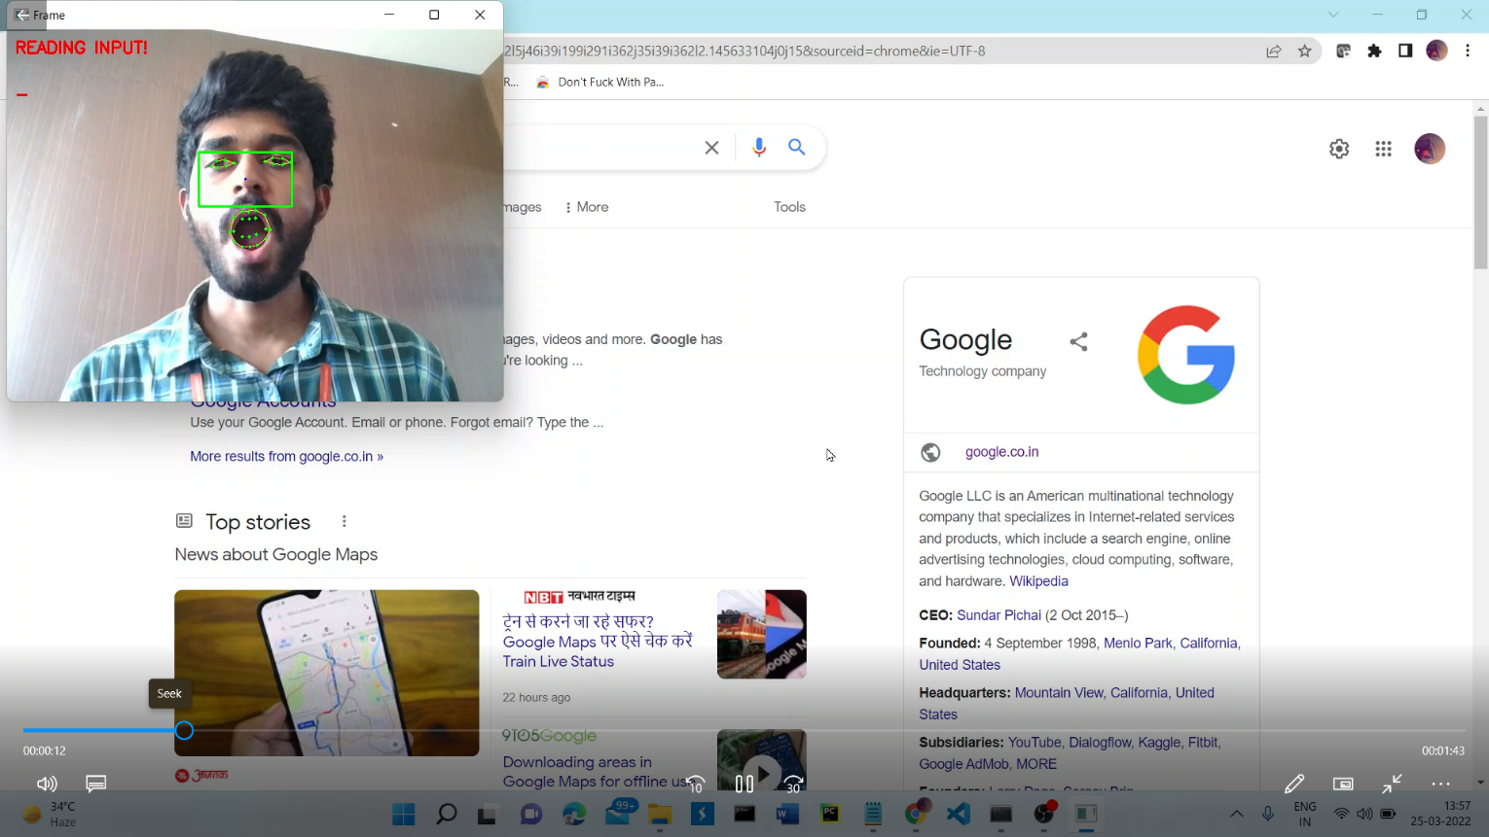**Activating the mouse – Reading Input**

Figure 6.1. Activating the mouse-Reading Input

The user needs to ‘yaw’ which is opening his mouth, vertically, in turn increasing the distance between the corresponding 2D points of the mouth. The algorithm detects the change in the distance by computing the ratio, and when this ratio crosses a specified threshold, the system is activated and the cursor can be moved.

**Moving the mouse pointer Left**

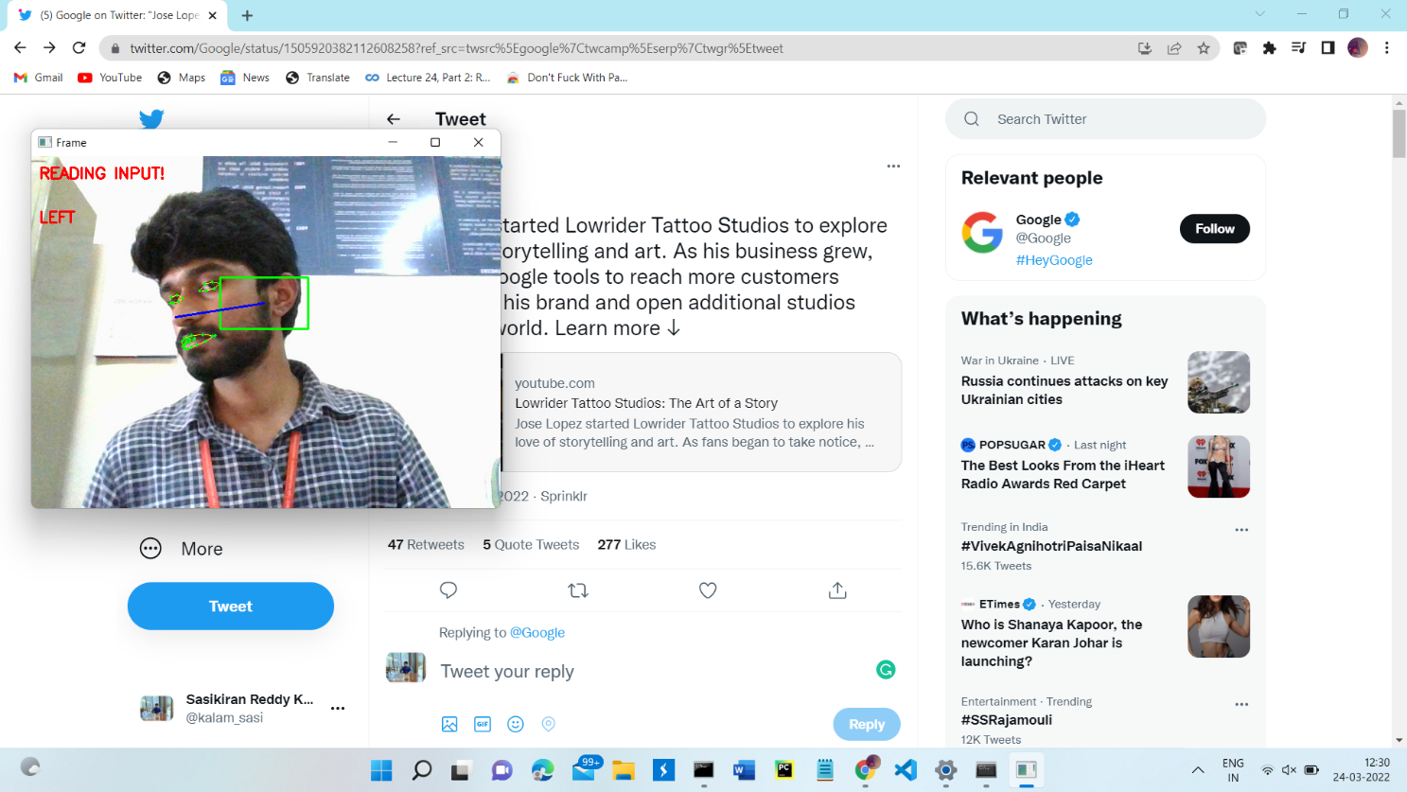

Figure 6.2. Moving the mouse pointer left

The user needs to place his nose towards, either the top, bottom, left or right of a rectangle that appears, to move the cursor in the corresponding direction. The more he is away from the rectangle, the faster is the movement of the cursor.

**Moving the mouse pointer Right**



Figure 6.3. Moving the mouse pointer right

The user needs to place his nose towards, either the top, bottom, left or right of a rectangle that appears, to move the cursor in the corresponding direction. The more he is away from the rectangle, the faster is the movement of the cursor.

**Moving the mouse pointer Up**

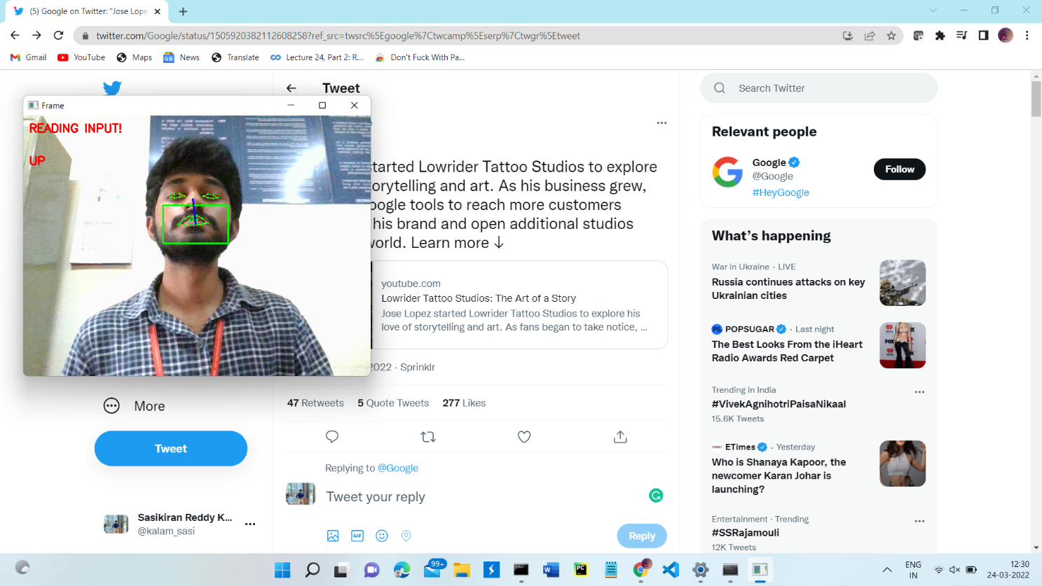

Figure 6.4. Moving the mouse pointer up

The user needs to place his nose towards, either the top, bottom, left or right of a rectangle that appears, to move the cursor in the corresponding direction. The more he is away from the rectangle, the faster is the movement of the cursor.

**Moving the mouse pointer Down**

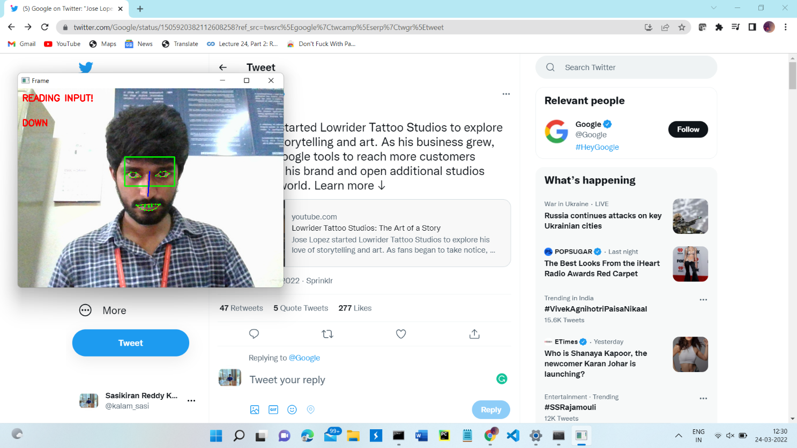

Figure 6.5. Moving the mouse pointer down

The user needs to place his nose towards, either the top, bottom, left or right of a rectangle that appears, to move the cursor in the corresponding direction. The more he is away from the rectangle, the faster is the movement of the cursor.

**Scrolling the pointer upwards**

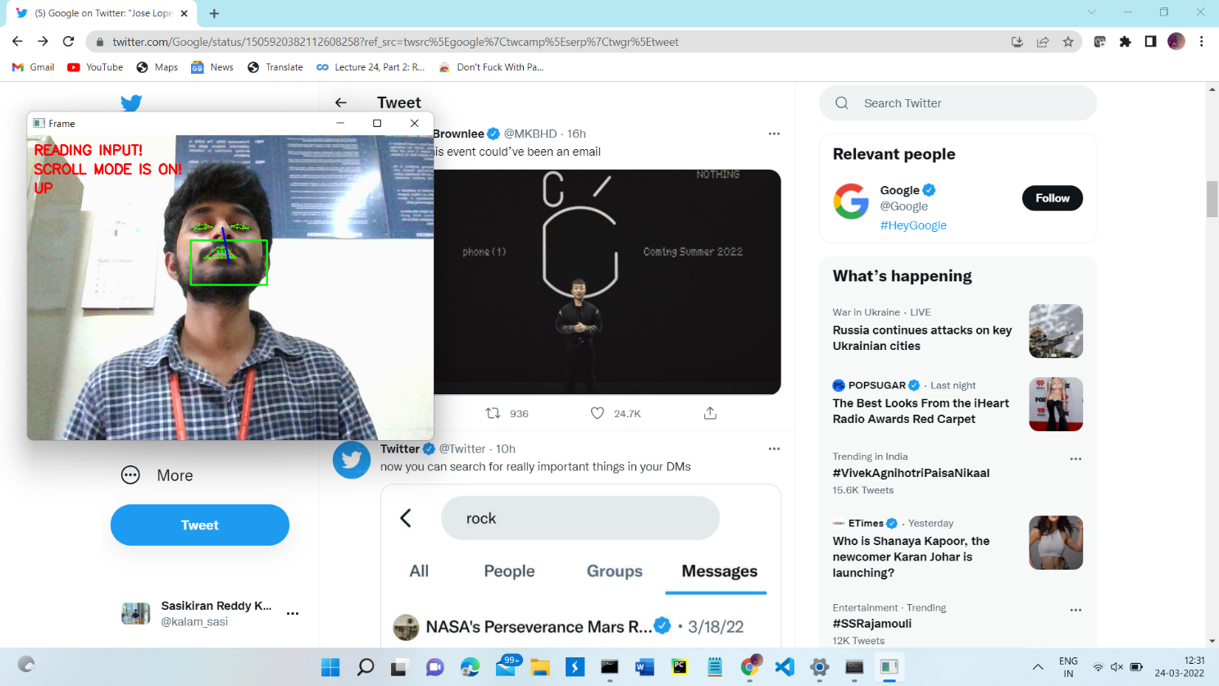

Figure 6.6. Scrolling the pointer Upwards

The user can scroll the mouse, either upwards or downwards. He needs to squint his eyes in such a way that the aspect ratio of both the eyes is less than the prescribed value. In this case, when the user places his nose outside the rectangle, the mouse performs scroll function, rather than moving the cursor. He can move his nose either above the rectangle to scroll upwards, or move it below the rectangle to scroll downwards.

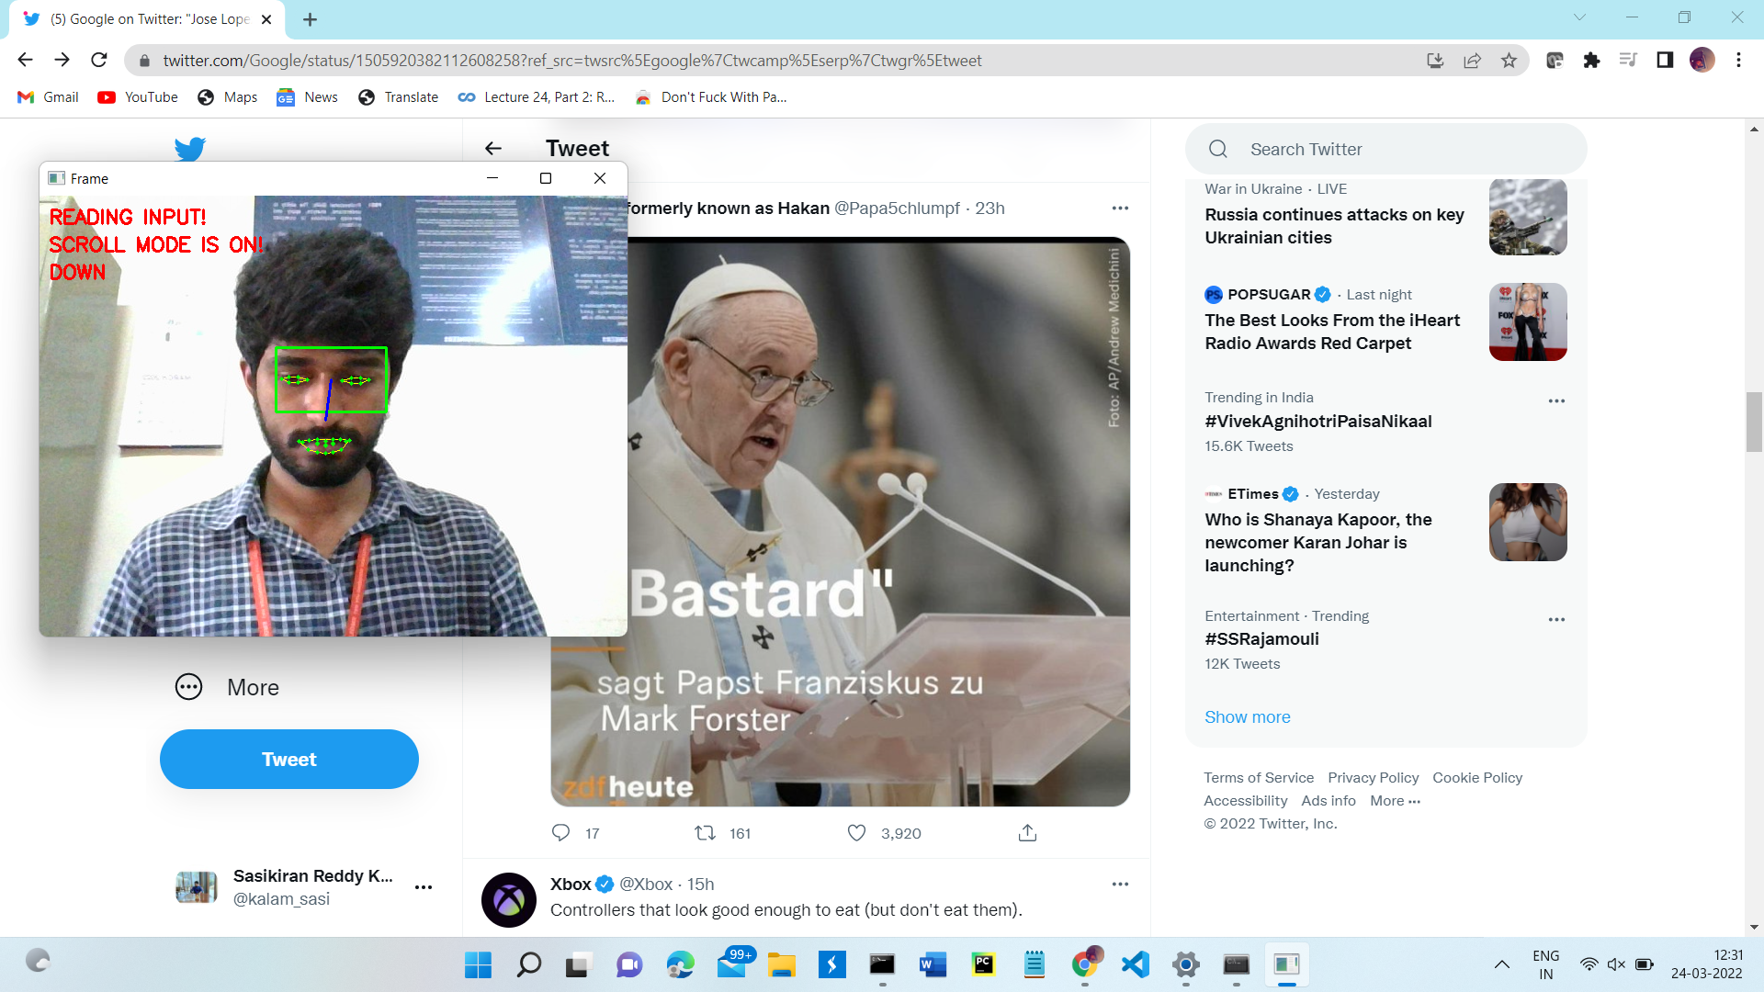**Scrolling the pointer downwards**

Figure 6.7. Scrolling the pointer Downwards

The user can scroll the mouse, either upwards or downwards. He needs to squint his eyes in such a way that the aspect ratio of both the eyes is less than the prescribed value. In this case, when the user places his nose outside the rectangle, the mouse performs scroll function, rather than moving the cursor. He can move his nose either above the rectangle to scroll upwards, or move it below the rectangle to scroll downwards.

**De-activating the mouse**

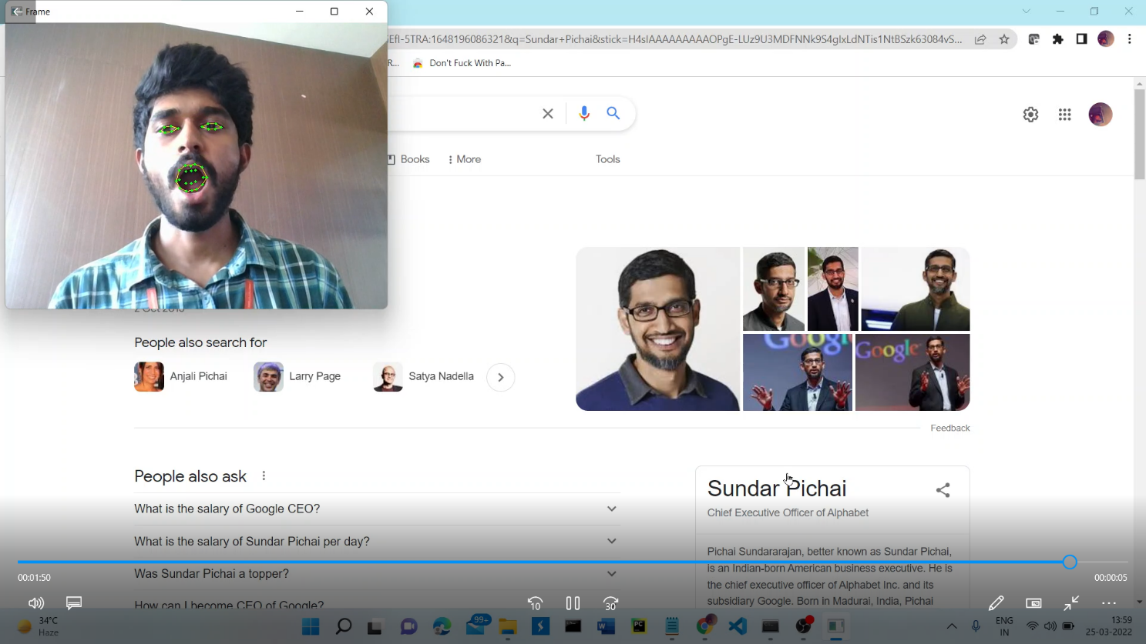

Figure 6.8. Deactivating the mouse

The user needs to ‘yaw’ which is opening his mouth, vertically, in turn increasing the distance between the corresponding 2D points of the mouth. The algorithm detects the change in the distance by computing the ratio, and when this ratio crosses a specified threshold, the system is activated and the cursor can be moved. But, again performing the ‘yaw’ operation deactivates the mouse.

‘

**7. TESTING METHODOLOGY**

|  |  |  |  |  |
| --- | --- | --- | --- | --- |
| **S.No.** | **Description** | **Expected**  **Output** | **Actual**  **Output** | **Result** |
| 1. | Load Dataset – Facial Landmark Dataset | Read Dataset | Load Dataset | Success |
| 2. | Capture Frame from camera – Video Stream | Need to read frame from camera | Reading Frame is done | Success |
| 3. | Detect Face – Gray Scale Image | Need to extract face region from given grayscale image | Face Detected Successfully | Success |
| 4. | Detect Facial Features – Face Bounding Box Region | Need to extract eye mouse nose contours | Contours generated | Success |
| 5. | Calculate Aspect ratio – Starting and Ending point | Need to calculate the aspect ratio of given contour | Aspect ratio Calculated | Success |
| 6. | Activating the Mouse | Mouse to be activated | Reading input | Success |
| 7. | Cursor Movement (Up) | Pointer to move upwards | Moving Up | Success |
| 8. | Cursor Movement (Down) | Pointer to move downwards | Moving Downwards | Success |
| 9. | Cursor Movement (Left) | Pointer to move Leftwards | Moving Leftwards | Success |
| 10. | Cursor Movement (Right) | Pointer to move Rightwards | Moving Rightwards | Success |
| 11. | Left Click – Left eye wink | Left Click to be activated | Left Click Activated | Success |
| 12. | Right Click – Right eye wink | Right Click to be activated | Right Click Activated | Success |
| 13. | Scroll Activation – Squinting both eyes | Scroll to be activated | Scroll mode on | Success |
| 14. | Scroll Down | Scrolling downwards | Scroll mode on -Down | Success |
| 15. | Scroll Up | Scrolling upwards | Scroll mode on –  Up | Success |
| 16. | Deactivating the Mouse | Mouse to be Deactivated | Mouse Deactivated | Success |

Table 7.1

In the above table, we have taken sixteen test cases and verified the expected output with the actual output and when the two are the same, then we can say that the specific test case is Passed

**8. CONCLUSION & FUTURE ENHANCEMENTS**

**8.1. Conclusion**

This work can be extended to improve the speed of the system by using better-trained models. Also, the system can be made more dynamic by making the change in the position of the cursor, proportional to the amount of rotation of the user’s head, i.e., the user can decide, at what rate he wants the position of the cursor to change. Also, future research work can be done on making the ratio more accurate, since the range of the values is the result of the aspect ratios, which are usually small. Hence, to make the algorithm detect the actions more accurately, there can be some modifications in the formulae for the aspect ratios used. Also, to make the process of detection of the face more easily, some image processing techniques can be used before the model detects the face and features of the face.

**8.2. Future Enhancements**

In future, many people who are unable to operate a standard computer mouse or keyboard because of disabilities of their hands or arms, can get possible alternative in multimodal system, which allows controlling a computer without using standard mouse and keyboard. Using head movements to control the cursor across the computer screen and by using the speech for giving the control commands. Automatic speech recognition and head tracking in joint multimodal action are combined to operate the system.

**9. REFERENCES**

[1] Alex Poole and Linden J. Ball, “Eye Tracking in Human-Computer Interaction and Usability Research: Current Status and Future Prospects,” in Encyclopedia of Human Computer Interaction (30 December 2005) Key: citeulike:3431568, 2006, pp. 211-219.

[2] D. H. Yoo, J. H. Kim, B. R. Lee, and M. J. Chung, “Non-contact Eye Gaze Tracking System by Mapping of Corneal Reflections,” in Fifth IEEE International Conference on Automatic Face and Gesture Recognition (FGR02), 2002, pp. 94-99.

[3] Rafael Barea, Luciano Boquete, Manuel Mazo, and Elena Lpez, “System for assisted mobility using eye movements based on electrooculography,” IEEE TRANSACTIONS ON NEURAL SYSTEMS AND REHABILITATION ENGINEERING, vol. 10, no. 4, pp. 209-217, DECEMBER 2002.

[4] H. Singh and J. Singh, “A Review on Electrooculography,” International Journal of Advanced Engineering Technology, vol. III, no. IV, 2012.

[5] K. Irie, B. A. Wilson, and R. D. Jones, “A laser-based eye-tracking system,” Behavior Research Methods, Instruments, & Computers, vol. 34, no. 4, pp. 561-572, 2002.

[6] P Ballard and George C. Stockman, “Computer operation via face orientation,” in Pattern Recognition, 1992. Vol.I. Conference A: Computer Vision and Applications, Proceedings., 11th IAPR International Conference on, 1992, pp. 407-410.

[7] T. Horprasert, Y. Yacoob, and L.S. Davis, “Computing 3-D head orientation from a monocular image sequence,” in Second International Conference on Automatic Face and Gesture Recognition, 1996, pp. 242- 247.

[8] K. Arai and M. Yamaura, “Computer Input with Human Eyes-Only Using Two Purkinje Images Which Works in a Real-Time Basis without Calibration,” CSC Journals, vol. 1, no. 3, pp. 71-82, 2010.

[9] D. Back, “Neural Network Gaze Tracking using Web Camera.,” Linkping University, MS Thesis 2005. [10] R. Gonzalez and R. Woods, Digital Image Processing, 3rd ed.: Pearson Education, 2009.

[11] P. Viola and M. Jones, “Rapid Object Detection using a Boosted Cascade of Simple Features,” in COMPUTER VISION AND PATTERN RECOGNITION, 2001.